Please make a Google search and provide the required details below:

Seller Contact - 1

Phone:
Name:
Address:
E-mail:

Specifications
Year: | 2018
Manufacturer: | Chevrolet
Model: | Express 3500
Engine: | 6.0L V8
Engine Model: | GM Vortex 6000
Horsepower: | 342HP
Transmission: | Automatic
Color: | White
Item Price: | $34,577, Financing Available($5000 down, $550/Month)

Seller Contact - 2

Phone:
Name:
Address:
E-mail:

Specifications
Year: | 2018
Manufacturer: | Isuzu
Model: | NPR-HD
Engine: | 5.2L V4
Engine Model: | Isuzu 4HK1-TC
Horsepower: | 215 HP
Transmission: | Automatic
Color: | White
Item Price: | $39,970, Financing Available($3270 down, $550/month)

Seller Contact - 3

Phone:
Name:
Address:
E-mail:

Specifications
Year: | 2018
Manufacturer: | Ford
Model: | E350
Engine: | 6.8L V10
Engine Model: | EFI Triton
Horsepower: | 305 HP
Transmission: | Automatic
Color: | White
Item Price: | $29,694

Photos
Sample #1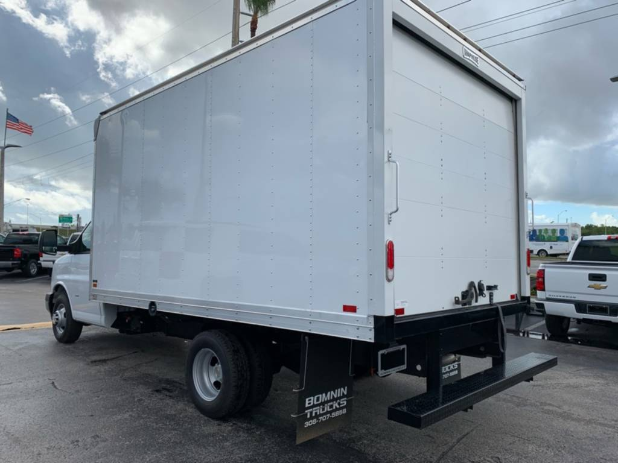
Sample #2
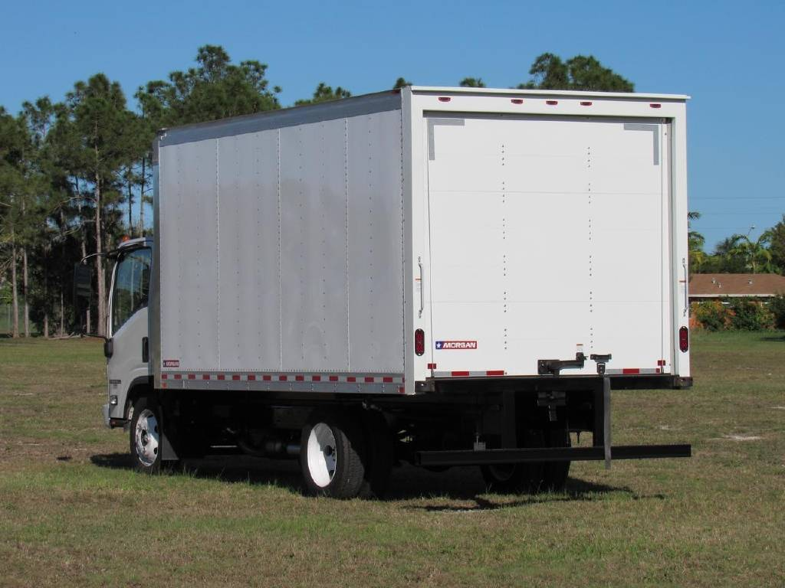

Sample #3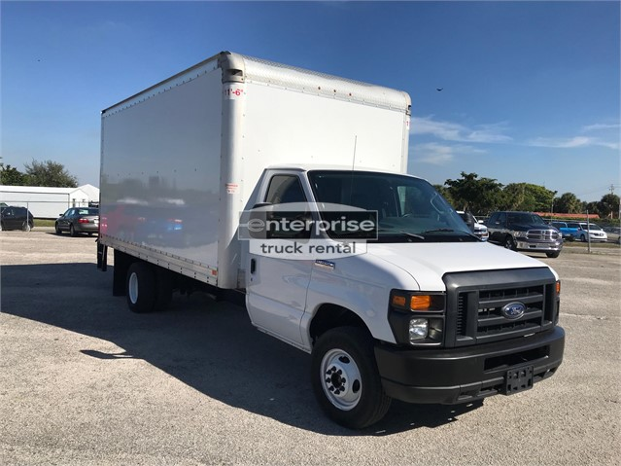

Date: First & Last Name:

