Comparative Price Range Research

Leasing Contact 1:
Name: | Curtis Tillett
Phone: | (217) 726-3298
Address: | 675 Linton, Springfield, IL 62703
E-mail: | curtis@curtistillett.com
Approximate Price Asked Per Month / Per Annum ($): | $1,759 per month  $21,105 per year
Number of Floors: | 1
Building Class: | B
Building Size: | 1,407
Year Built: | 1994
Comments:

Photos
Sample #1 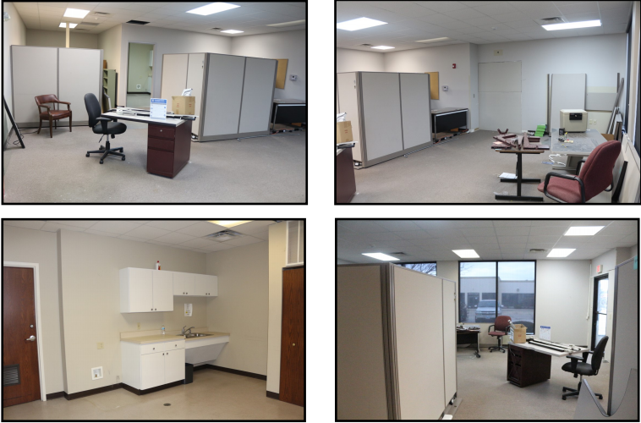
Sample #2 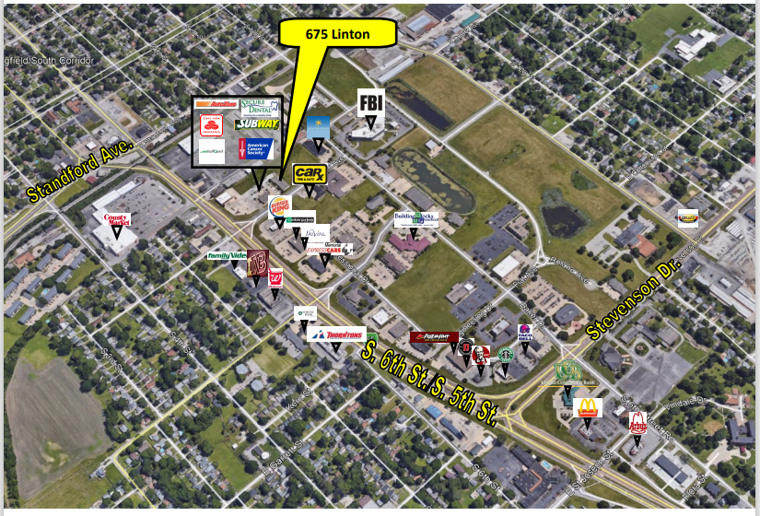

Leasing Contact 2:
Name: | Tyler Smith
Phone: | (217)652-7516
Address: | 350 E Madison St, Springfield, IL 62701
E-mail: | tyler@garrisongroupinc.com
Approximate Price Asked Per Month / Per Annum ($): | $1,096 per month  $13,152 per year
Number of Floors: | 3
Building Class: | A
Building Size: | 1,196 sqft
Year Built: | 2016
Comments: | Call preferred. No photos available online. Sending them via email.

Photos
Sample #1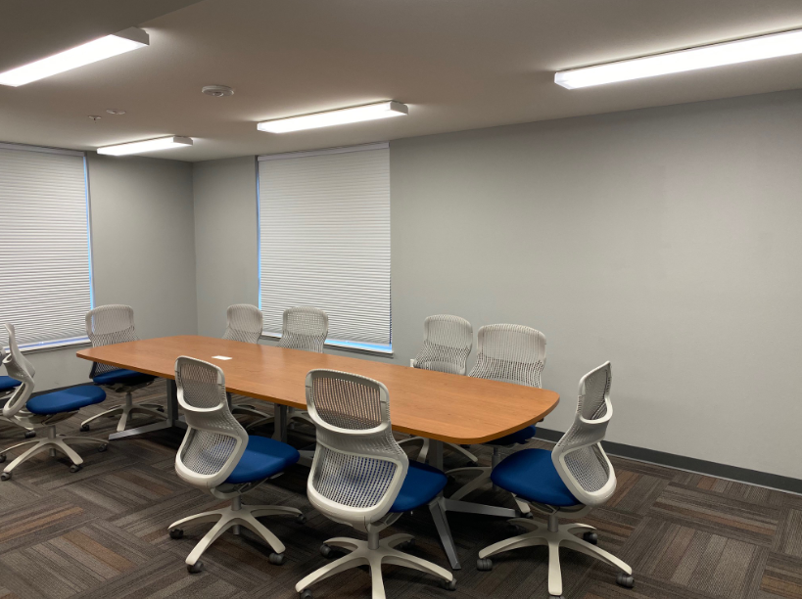
Sample #2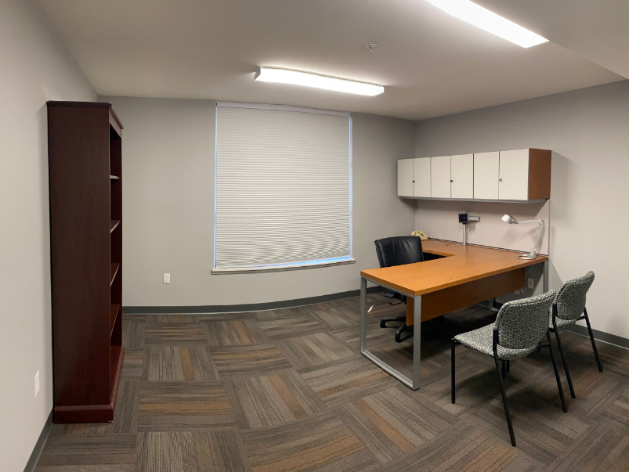

Leasing Contact 3:
Name: | Dennis Albanese
Phone: | 217-899-3400
Address: | 319 E Madison St. Springfield, IL
E-mail: | dennisalbanese@gmail.com
Approximate Price Asked Per Month / Per Annum ($): | $1,450 per month  $17,400‬ per year
Number of Floors: | 4
Building Class: | A
Building Size: | 83,022 sqft
Year Built: | 1990/2017 renovation
Comments: | Free parking. Space to rent is 1,450 sqft, located on the 2nd floor. Ste 2B. Landlord pays water, sewer, taxes, insurance.

Photos
Sample #1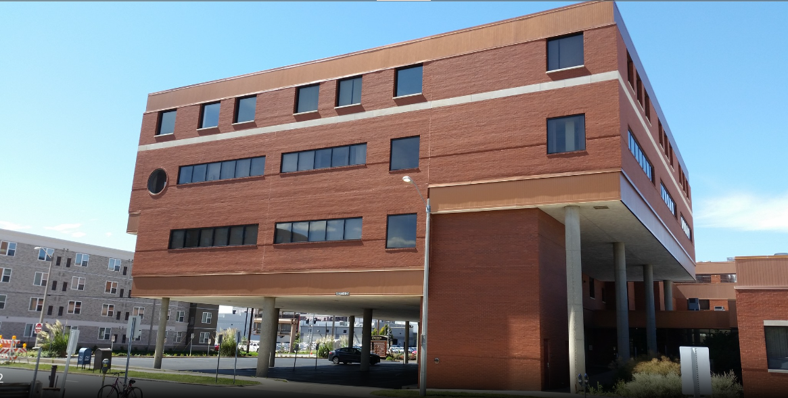
Sample #2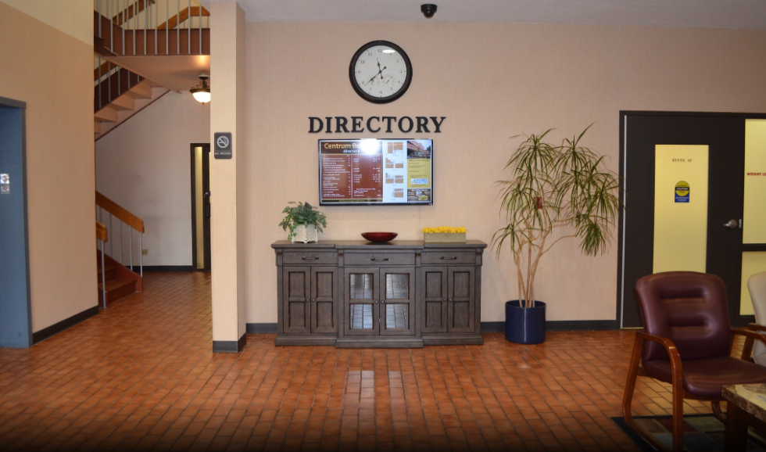

Date: First & Last Name:

